REPORT FOR ASSIGNMENT 2

**Handwritten Digit Recognition**

1st MODEL Accuracy = (100 - Pred != True) % = (100-18)% = 82%

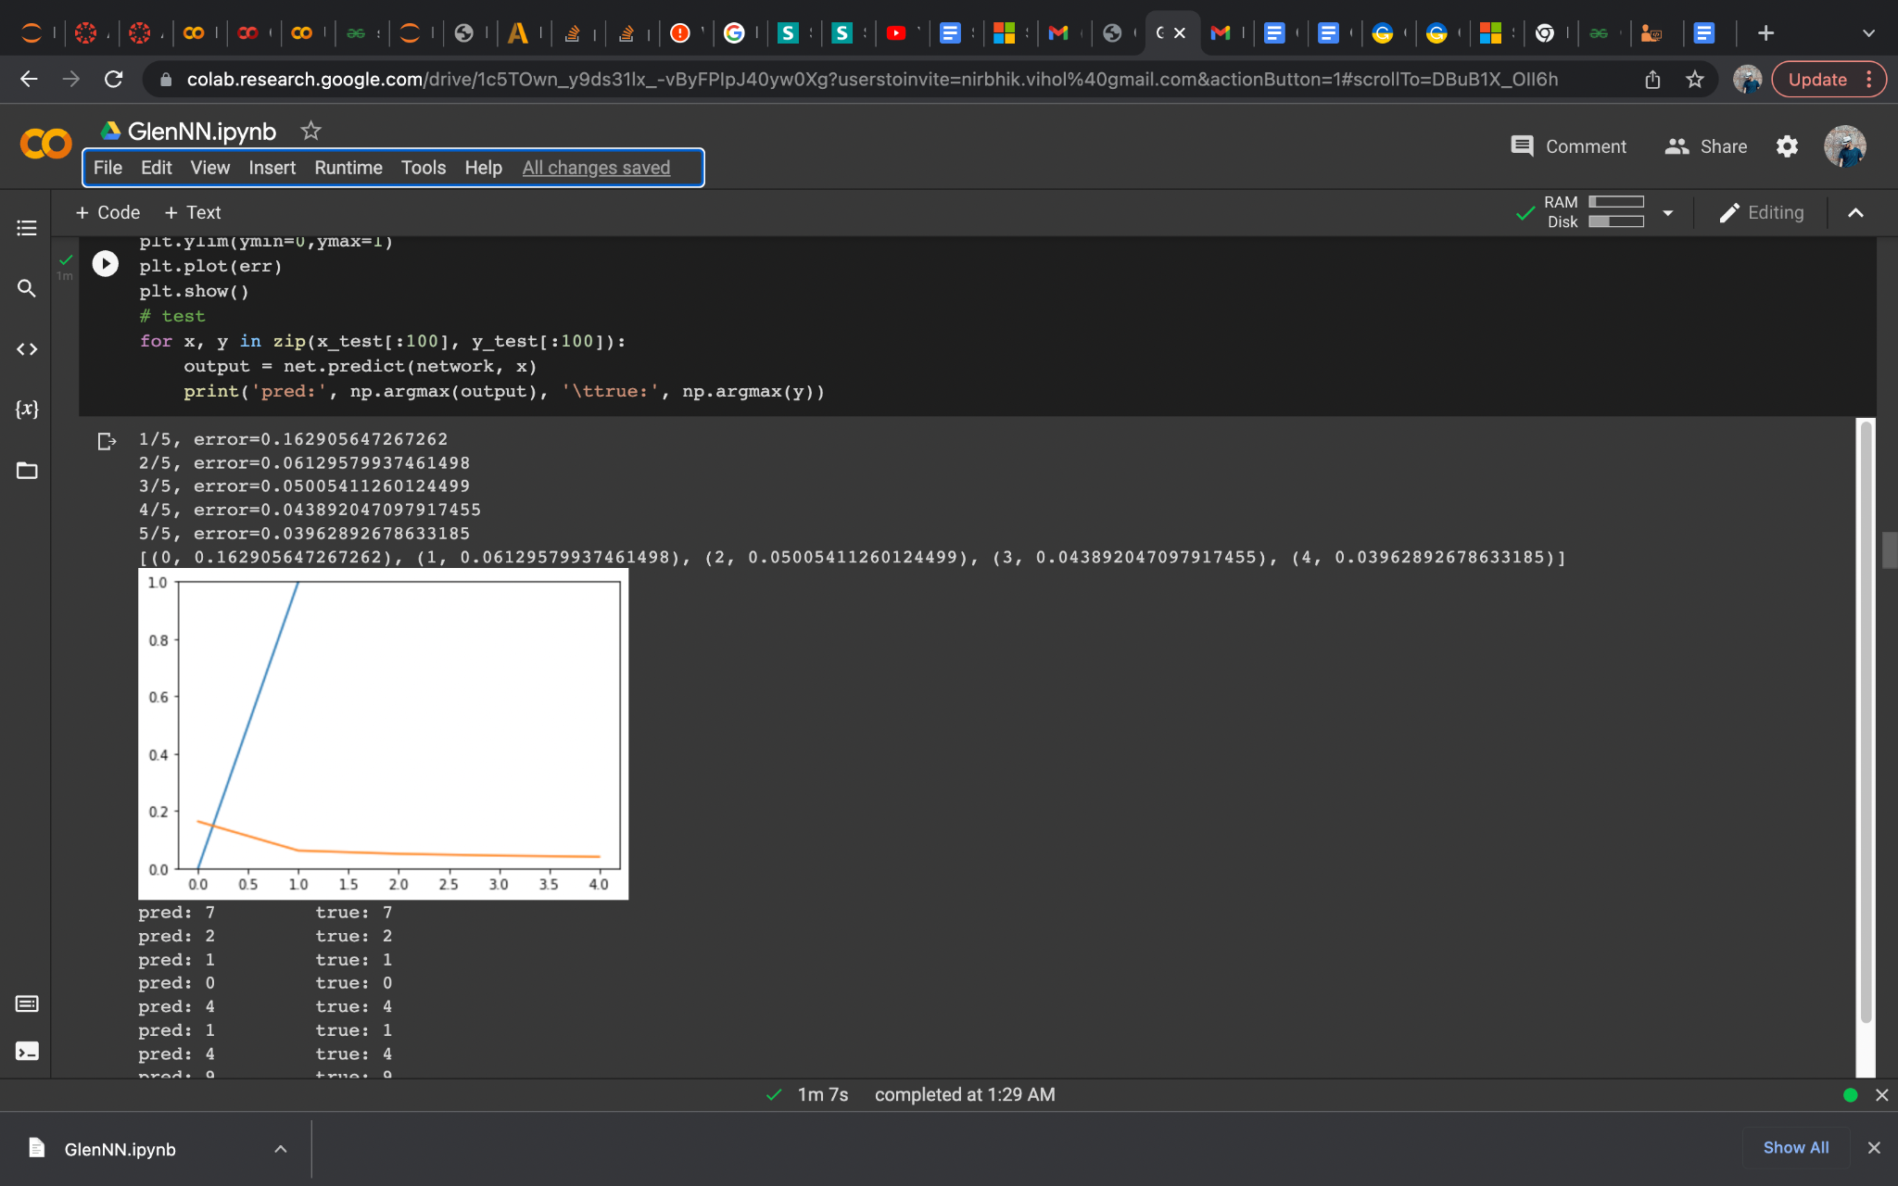

2nd MODEL Accuracy = (100 - Pred != True) % =(100-8) = 92%

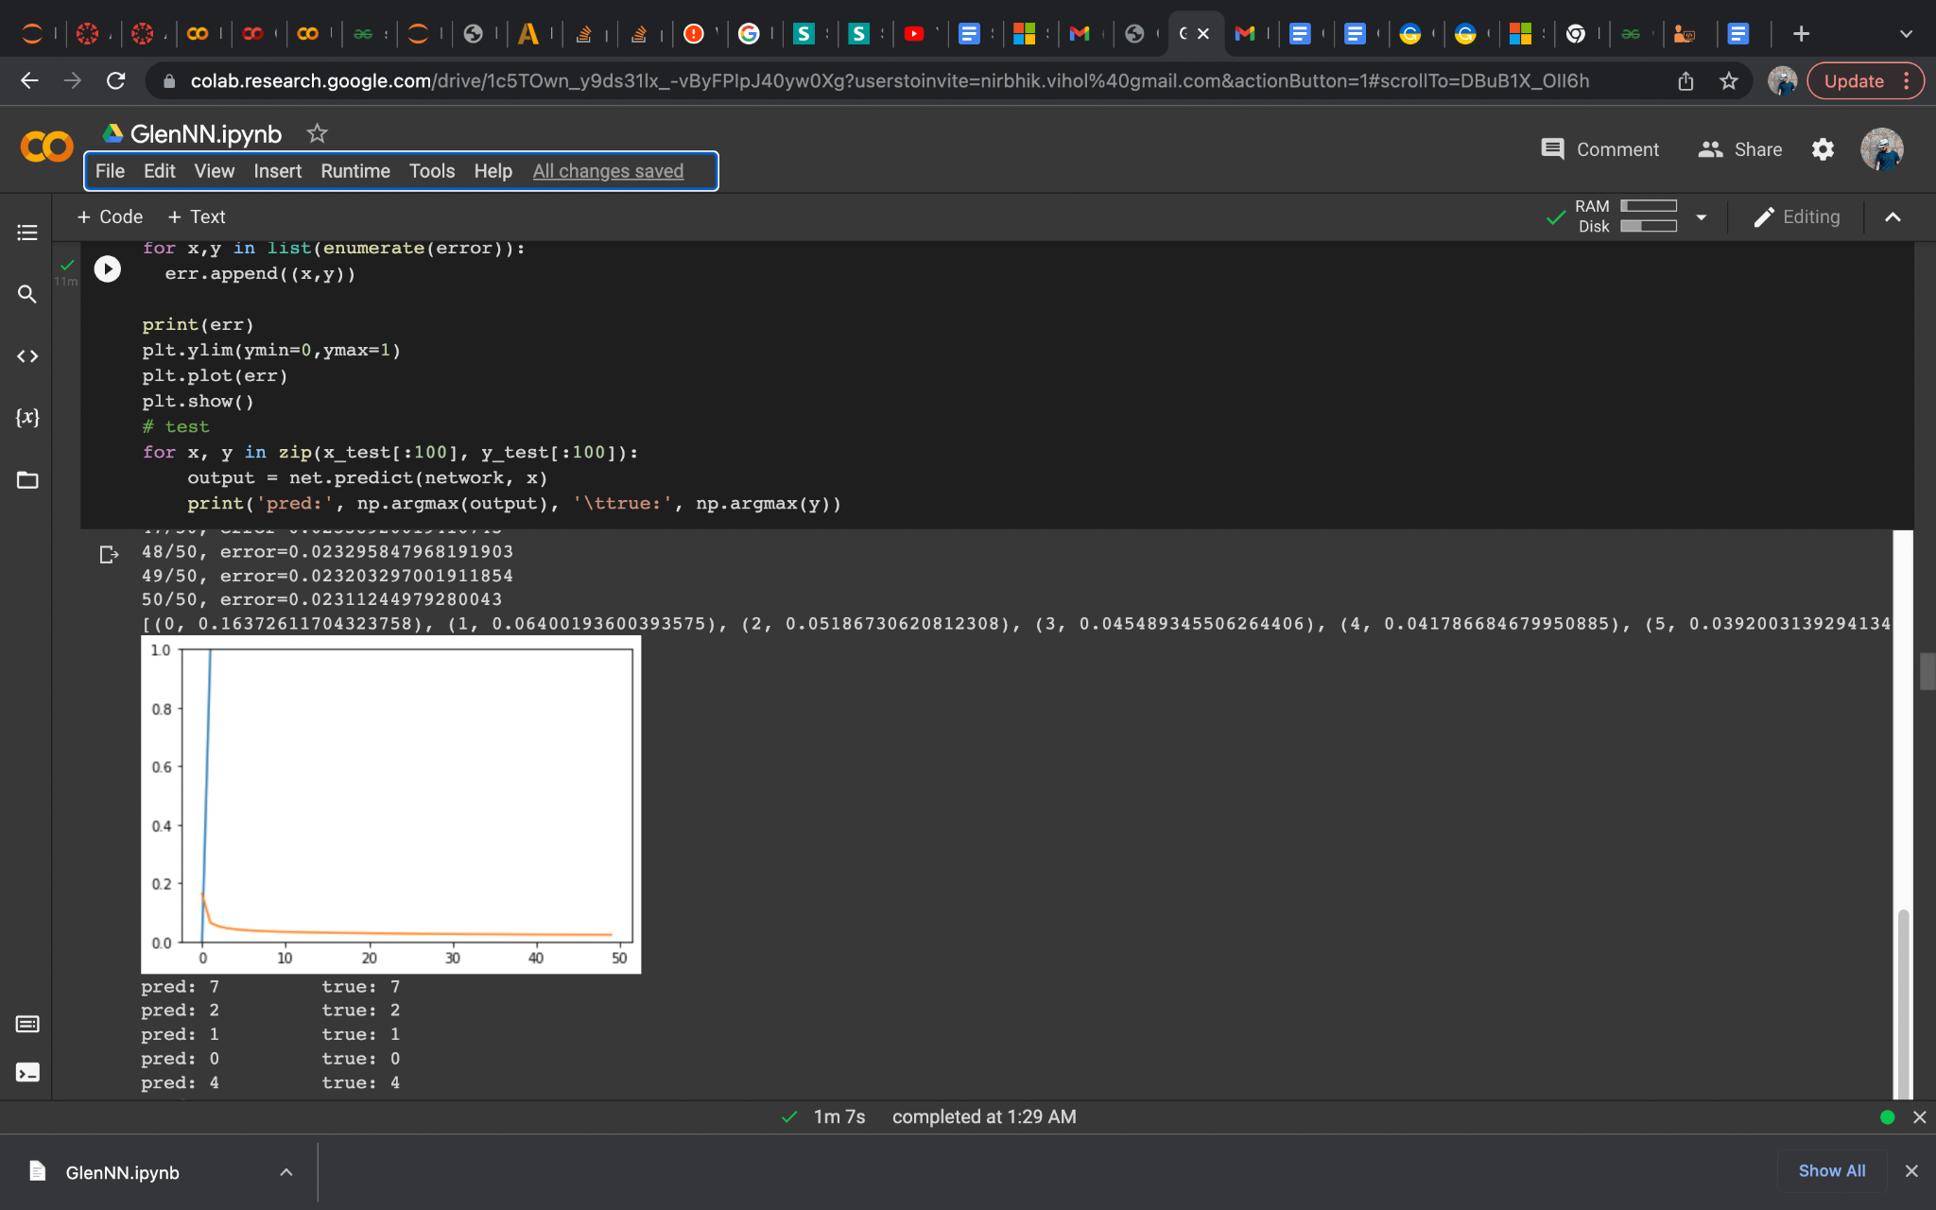

3rd MODEL Accuracy = (100 - Pred != True) % =(100-8) = 92%

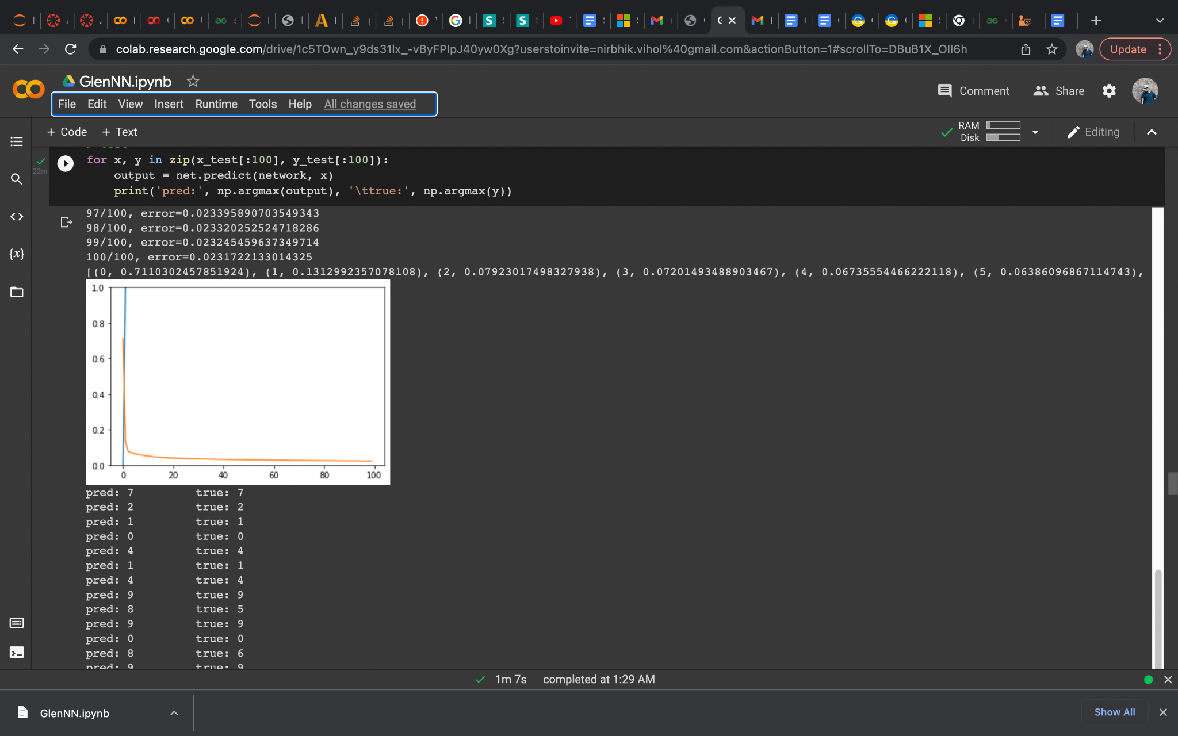

**Playing with Hyperparameters**

Learning Rate 1

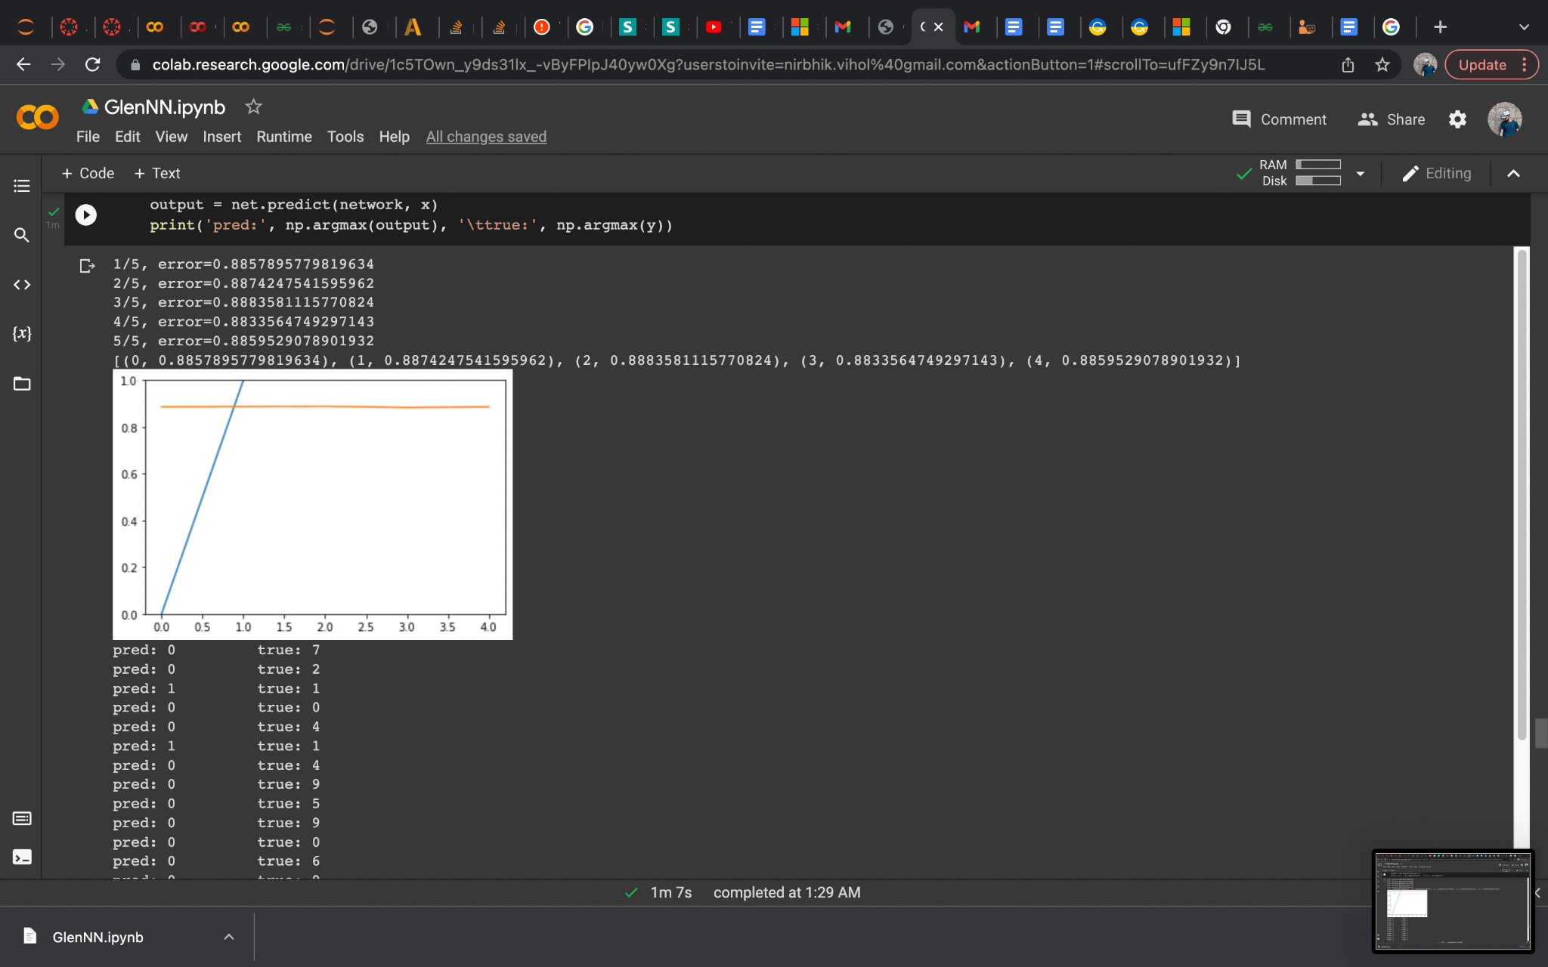

Learning Rate 0.001

